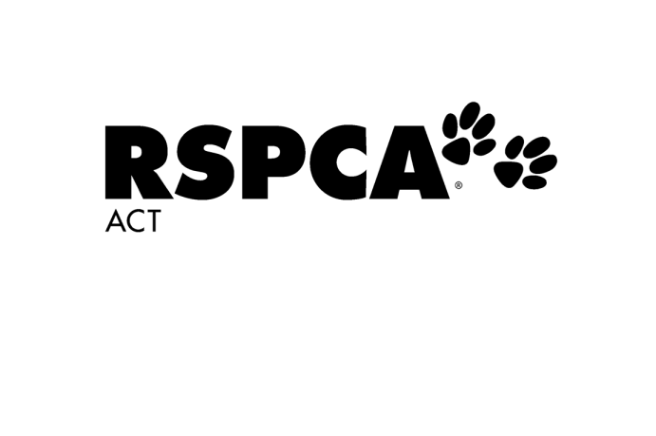

**Office Use Only**

Allergies/Medical/Special Requirements

Photos?  Yes  No – photo supplied

Form Completed in Full   
Payment Received

Staff Initials:

**Kids N Kritters Enrolment Form**

Which Kids N Kritters session would you like to attend?

Session Date: (select date)

Session One  Both Sessions

Session Two  Level 2 (9am-4pm*)

**Your Details**



Full Name:



Address:



Email Address:



Mobile Number:



Emergency Contact Name:



Emergency Contact Number:

**Participant details**



Full Name:

Date of Birth: Gender:  Male Female

Does the participant have any allergies or medical conditions?

No  Yes – I will attach an action plan along with this form

I confirm that all information above is correct and understand the *terms and conditions* (page 2)

I allow my child to be in photographs that may be used to promote RSPCA programs in the future; web, social media and print

I do not allow my child to be in photographs that may be used to promote RSPCA programs in the future; web, social media and print. I will supply a photograph of my child that will be used only as an identifier so they can be exept from all photos (Email: [pac@rspca-act.org.au](mailto:pac@rspca-act.org.au))

I would like to be added to the RSPCA ACT mailing list and go into a quarterly draw to win one of two RSPCA ACT gift vouchers valued at $75

**I found out about Kids N Kritters: (please select one)**

Return Participant  Holiday Happenings  Facebook  Instagram Internet Search

RSPCA Website  Recommendation  RSPCA Newsletter  Other:



Payment

I would like to pay by:  Over the phone  Mastercard  VISA



Name on Card:



Card Number



Expiry Date: CCV Number:

**Terms and Conditions**

* Bookings will not be made without payment.
* RSPCA ACT reserves the right to cancel or change any advertised activity when unavoidable.
* Program activities are conducted by RSPCA ACT staff with the assistance of volunteers (all hold current working with vulnerable person’s cards).
* Participants will be involved in supervised, hands-on activities
* During the session participants may encounter a range of animals such as: dogs, cats, rats, chickens, rabbits, and guinea pigs.
* If a participant puts themselves, others or animals at risk, or does not display appropriate behaviour they will be removed from the program. Their parent/guardian will be required to collect them in a timely manner and no refund will be given
* RSPCA ACT will not be responsible for damage to or loss of personal items
* Participants are required to bring their own labelled water bottle and snack or lunch and snack if they are participating in consecutive or Level 2 sessions (food items must be nut and egg free).
* For safety reasons all participants must wear the appropriate clothing. Appropriate clothing includes a hat, closed toe shoes and warm clothing on cooler days. Thongs and sandals are not acceptable footwear. A participant will be refused entry if not dressed appropriately. Participants are advised to wear sunscreen.
* Parents/guardians are not able to attend a session with their child. Parents/guardians are welcome to wait in our waiting area for the duration of the session. Under special circumstances a parent /guardian may obtain permission to attend, however the parent/guardian is required to hold a WWVP card and pay the participant fee in full.
* It is my responsibility as parent/guardian to ensure my child is collected on time and no later than 5 minutes from the end of the session. I understand that should I arrive late I will be required to pay $60 for my child to attend the following class or $60 for staff to care for my child in my absence.
* The RSPCA ACT reserves the right to ask for identification when collecting a participant from a session.
* 100% refund will be given if more than 2 business days’ notice has been given prior to cancellation
* 50% refund will be given if less than 2 business days’ notice has been given prior to cancellation
* No refund will be given if cancellation is made on or after commencement of classes
* A refund may be given for special circumstances at the discretion of the Customer Service Manager. Requests for refund must be submitted via email to rspca@rspca-act.org.au
* Participants will be involved in a range of hands-on activities visiting various parts of the RSPCA ACT site. Activities may include visiting the veterinary clinic. I understand that while the RSPCA ACT takes all reasonable precautions to ensure the safety of participants, all participants enter at their own risk. I consent to the above mentioned participant taking part in activity sessions. By enrolling in these programs you acknowledge that you understand this disclaimer and release RSPCA ACT and its employees, agents, volunteers and contractors from any liability whatsoever, to the extent permitted by law.

Please email completed form

[pac@rspca-act.org.au](mailto:pac@rspca-act.org.au)